**.NET(C#)**

**1.Write a console application that obtains two int values from the user and**

**displays the**

**a. ADD**

**b. SUBTRACT**

**c. MULTIPLY**

**d. DIVISION**

**e. MOD**

**code:-**

using System;

using System.Collections.Generic;

using System.Linq;

using System.Text;

using System.Threading.Tasks;

namespace program1

{

class Calculator

{

private int a;

private int b;

private int sum,substraction ,multiplication ,division,mod;

public Calculator(int a,int b)

{

this.a = a;

this.b = b;

}

public void calculation()

{

sum = a + b;

substraction = a - b;

multiplication = a * b;

division = a / b;

mod = a % b;

Console.WriteLine("sum of "+a+" and "+b+" number :" + sum);

Console.WriteLine("subtract of " + a + " and "+ b + " number :" + substraction);

Console.WriteLine("Multiply of " + a + " and "+b + " number :" + multiplication);

Console.WriteLine("Division of " + a + " and "+ b + " number :" + division);

Console.WriteLine("Mod of " + a + " and "+ b + " number :" + mod);

}

}

class Program

{

static void Main(string[] args)

{

Console.WriteLine("Enter your 1st number :");

int n1 = Convert.ToInt32(Console.ReadLine());

Console.WriteLine("Enter your 2nd number :");

int n2 = Convert.ToInt32(Console.ReadLine());

Calculator c = new Calculator(n1, n2);

c.calculation();

Console.ReadKey();

Console.ReadKey();

}

}

}

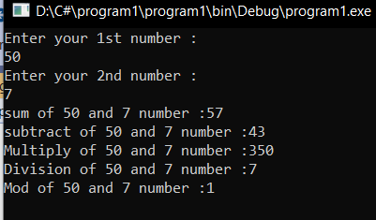

1. **Write programs using conditional statements and loops:**

**I)Generate Fibonacci series.**

using System;

using System.Collections.Generic;

using System.Linq;

using System.Text;

using System.Threading.Tasks;

namespace program2

{

internal class Program

{

static void Main(string[] args)

{

int a = 0, b = 1, n, c;

Console.WriteLine("Enter to no. of elements to print :");

n = Convert.ToInt32(Console.ReadLine());

Console.Write(a);

for (int i = 1; i <= n; i++)

{

c = a + b;

Console.Write(c + " ");

a = b;

b = c;

}

Console.ReadKey();

}

}

}

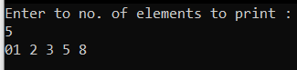

**II) Generate various patterns (triangles, diamond and other patterns) with numbers.**

using System;

using System.Collections.Generic;

using System.Linq;

using System.Text;

using System.Threading.Tasks;

namespace program2

{

internal class Program

{

static void Main(string[] args)

{

int n;

Console.WriteLine("Enter your number :");

n = Convert.ToInt32(Console.ReadLine());

for(int i = 1; i <= n; i++)

{

for(int j = 1; j <= i; j++)

{

Console.Write("* ");

}

Console.WriteLine();

}

Console.ReadKey();

}

}

}

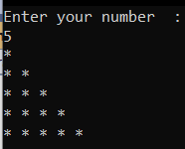

using System;

using System.Collections.Generic;

using System.Linq;

using System.Text;

using System.Threading.Tasks;

namespace program2

{

internal class Program

{

static void Main(string[] args)

{

int n;

Console.WriteLine("Enter your number :");

n = Convert.ToInt32(Console.ReadLine());

for(int i=0;i<n;i++)

{

for(int j=0;j<n;j++)

{

Console.Write(" &");

}

Console.WriteLine();

}

Console.ReadKey();

}

}

}

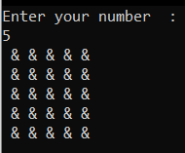

using System;

using System.Collections.Generic;

using System.Linq;

using System.Text;

using System.Threading.Tasks;

namespace program2

{

internal class Program

{

static void Main(string[] args)

{

int n;

Console.WriteLine("Enter your number :");

n = Convert.ToInt32(Console.ReadLine());

for (int i = 1; i <= n; i++)

{

for (int j = n - 1; j >= i; j--)

Console.Write(" ");

for (int x = 1; x <= i; x++)

Console.Write(" *");

Console.WriteLine();

}

for (int i = 1; i <= n; i++)

{

for (int j = 0; j < i; j++)

Console.Write(" ");

for (int x = 1; x <= n - i; x++)

Console.Write(" *");

Console.WriteLine();

}

Console.ReadKey();

}

}

}

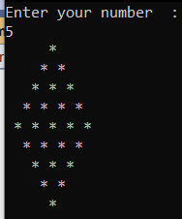

**III) Test for prime number**

using System;

using System.Collections.Generic;

using System.Linq;

using System.Text;

using System.Threading.Tasks;

namespace program3

{

internal class Program

{

static void Main(string[] args)

{

int count = 0;

Console.WriteLine("Enter your number to check prime or not :");

int n = Convert.ToInt32(Console.ReadLine());

for (int i = 1; i <= n; i++)

{

if (n % i == 0)

{

count++;

}

}

if (count == 2)

{

Console.WriteLine(n + " is a prime number .");

}

else

{

Console.WriteLine(n + " not a prime number !");

}

Console.ReadKey();

Console.ReadKey();

}

}

}

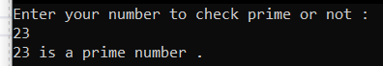

**3.Write a console application to add two matrices.**

using System;

using System.Collections.Generic;

using System.Linq;

using System.Text;

using System.Threading.Tasks;

namespace program3

{

internal class Program

{

static void Main(string[] args)

{

int[,] a = new int[2, 2];

int[,] b = new int[2, 2];

//int[,] c = new int[2, 2];

int i, j;

Console.WriteLine("Enter the 1st matrix elements :");

for (i = 0; i < 2; i++)

{

for (j = 0; j < 2; j++)

{

a[i, j] = Convert.ToInt32(Console.ReadLine());

}

}

Console.WriteLine("Enter the 2nd matrix elements :");

for (i = 0; i < 2; i++)

{

for (j = 0; j < 2; j++)

{

b[i, j] = Convert.ToInt32(Console.ReadLine());

}

}

Console.WriteLine("Additon of two matrixs is :");

for (i = 0; i < 2; i++)

{

for (j = 0; j < 2; j++)

{

Console.Write(a[i, j] + b[i, j] + " ");

}

Console.WriteLine();

}

Console.ReadKey();

}

}

}

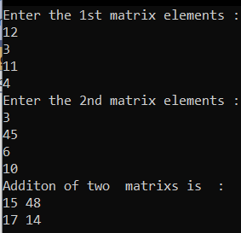

**4.Write code to get a calculator to validate and add numbers.**

using System;

using System.Collections.Generic;

using System.Linq;

using System.Text;

using System.Threading.Tasks;

namespace program4

{

internal class Program

{

static void Main(string[] args)

{

int n1 = 0, n2 = 0, choice;

retry:

try

{

Console.Write("Enter the first number : ");

n1 = Convert.ToInt32(Console.ReadLine());

Console.Write("Enter the second number :");

n2 = Convert.ToInt32(Console.ReadLine());

}

catch

{

Console.WriteLine("\n Enter Number only .");

Console.WriteLine("\n Please retry again .");

goto retry;

}

do

{

Console.WriteLine("1:Addition");

Console.WriteLine("2:Subtraction");

Console.WriteLine("3:Multipication");

Console.WriteLine("4:divition");

Console.WriteLine("5:Mod");

Console.WriteLine("6:Exit");

Console.Write("Enter your operation :");

choice = Convert.ToInt32(Console.ReadLine());

switch (choice)

{

case 1:

Console.WriteLine("Add:{0}", n1 + n2);

break;

case 2:

Console.WriteLine("Subtract:{0}", n1 - n2);

break;

case 3:

Console.WriteLine("Multiply:{0}", n1 * n2);

break;

case 4:

Console.WriteLine("Div:{0}", n1 / n2);

break;

case 5:

Console.WriteLine("Mod:{0}", n1 % n2);

break;

case 6:

System.Environment.Exit(0);

break;

default:

Console.WriteLine("invalid choice.");

break;

}

} while (choice != 6);

}

}

}

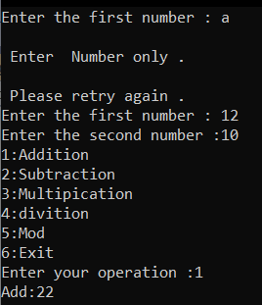

**5. Write a program to declare class “Distance” have data members dist1, dist2, dist3. Initialize the two data members using constructor and store their addition in third data member using function and display addition.**

using System;

using System.Collections.Generic;

using System.Linq;

using System.Text;

using System.Threading.Tasks;

namespace project5

{

class Distance

{

public int dist1;

public int dist2;

private int dist3;

public Distance(int d1,int d2)

{

dist1=d1 ;

dist2 = d2;

}

public void display()

{

dist3 = dist1 + dist2;

Console.WriteLine("Addition of two numbers are =" + dist3);

}

}

class Program

{

static void Main(string[] args)

{

Distance d = new Distance(20, 40);

d.display();

Console.ReadKey();

}

}

}

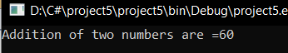

**6 Define a class “salary” which will contain member variable Basic, TA, DA, HRA. Write a program using Constructor with default values for DA and HRA and calculate the salary of employee.**

using System;

using System.Collections.Generic;

using System.Linq;

using System.Text;

using System.Threading.Tasks;

namespace program4

{

internal class Program

{

class Salary

{

public int Base =10000;

public double TA;

public double DA;

public int HRA;

double total;

public Salary()

{

DA = 2000;

HRA = 3000;

}

public double display()

{

TA = Base + Base * 0.3;

total = TA + DA + HRA;

Console.WriteLine("Base salary is =" + Base);

Console.WriteLine("TA salary is =" + TA);

Console.WriteLine("DA salary is =" + DA);

Console.WriteLine("HRA salary is =" + HRA);

Console.WriteLine("Total salary is =" + total);

return 0;

}

}

static void Main(string[] args)

{

Salary s = new Salary();

s.display();

Console.ReadKey(); }

}

}

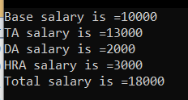

**7. Demonstrate Event Handling.**

using System;

using System.Collections;

using System.Collections.Generic;

using System.ComponentModel;

using System.Data; using System.Drawing;

using System.Linq; using System.Text;

using System.Threading.Tasks;

using System.Windows.Forms;

namespace WindowsForms

{

public partial class Form1 : Form

{

public Form1()

{

InitializeComponent();

}

private void textBox2_TextChanged(object sender, EventArgs e)

{

label2.Text = txtname.Text;

}

private void btnSubmit_Click(object sender, EventArgs e)

{

string radio;

string check;

if(gender1.Checked)

{

radio = "Male Select";

}

else if(gender2.Checked)

{

radio = "Female Select";

}

else

{

radio = "No One Select";

}

if(checkBox1.Checked)

{

check = "Java";

}

else if (checkBox2.Checked)

{

check = ".Net";

}

else

{

check = "No One Select";

}

MessageBox.Show("RadioBox value : "+radio+" CheckBox Value : "+check);

}

RadioButton rb = new RadioButton();

private void addBtn_Click(object sender, EventArgs e)

{

AddNewBtn();

}

private void AddNewBtn()

{

rb.Text = "New Btn";

rb.Name = "newRadio";

GrpBox.Controls.Add(rb);

}

private void removeBtn_Click(object sender, EventArgs e)

{

GrpBox.Controls.Remove(rb);

}

private void btn2_Click(object sender, EventArgs e)

{

txt2.Text = "Mouse Click Event Call";

}

private void btn2_MouseDown(object sender, MouseEventArgs e)

{

txt2.Text = "Mouse Down Event Call";

}

private void btn2_MouseEnter(object sender, EventArgs e)

{

txt2.Text = "Mouse Enter Event Call";

}

private void btn2_MouseHover(object sender, EventArgs e)

{

txt2.Text = "Mouse Hover Event Call";

}

private void btn2_MouseLeave(object sender, EventArgs e)

{

txt2.Text = "Mouse Leave Event Call";

}

private void btn2_MouseMove(object sender, MouseEventArgs e)

{

txt2.Text = "Mouse Move Event Call";

}

private void btn2_MouseUp(object sender, MouseEventArgs e)

{

txt2.Text = "Mouse Up Event Call";

}

private void txt2_KeyDown(object sender, KeyEventArgs e)

{

label3.Text = "KeyDown Call";

label3.Text = $"{e.Modifiers}"; //Display Alt,Ctrl,Shift

}

private void txt2_KeyPress(object sender, KeyPressEventArgs e)

{

label3.Text = "KeyPress Call";

label3.Text = $"{e.KeyChar}"; //Display Key Name

}

private void txt2_KeyUp(object sender, KeyEventArgs e)

{

label3.Text = $"{e.KeyCode}";

label3.Text = $"{e.KeyData}";

label3.Text = $"{e.KeyValue}";

}

private void btnList_Click(object sender, EventArgs e)

{

ArrayList a = new ArrayList();

a.Add("Kiwi");

a.Add("Water Malon");

a.Add("Graps");

listBox1.DataSource = a;

}

}

}

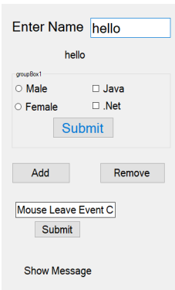

**8.Demonstrate Delegates.**

using System;

using System.Collections.Generic;

using System.Linq;

using System.Text;

using System.Threading.Tasks;

namespace program8

{

public delegate int delmethod1(int a, int b);

public delegate void delmethod2();

internal class Program

{

public static void show()

{

Console.WriteLine("Show Method is Called.");

}

public static int display(int a, int b)

{

return a + b;

}

static void Main(string[] args)

{

delmethod2 d = Program.show;

d();

delmethod1 d1 = Program.display;

int c = d1(100, 75);

Console.WriteLine("Sum is = " + c);

Console.ReadKey();

}

}

}



using System;

using System.Collections.Generic;

using System.Linq;

using System.Text;

using System.Threading.Tasks;

namespace program8

{

class Program

{

public delegate void Multi_Delegate();

public class Deligation

{

public static void display()

{

Console.WriteLine("Display method Call.");

}

public static void print()

{

Console.WriteLine("Print method Call.");

}

}

static void Main(string[] args)

{

Multi_Delegate d1 = new Multi_Delegate(Deligation.display);

Multi_Delegate d2 = new Multi_Delegate(Deligation.print);

Multi_Delegate d3 = d1 + d2;

Multi_Delegate d4 = d1 - d2;

Console.WriteLine("d3 is called .");

d3();

Console.WriteLine("d4 is called .");

d4();

Console.ReadKey();

Console.ReadKey();

}

}

}

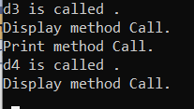

**9. Demonstrate Exception Handling**

**Built in Exception:**

using System;

using System.Collections.Generic;

using System.Linq;

using System.Text;

using System.Threading.Tasks;

namespace program9

{

internal class Program

{

static void Main(string[] args)

{

try

{

int a = 9;

int b = 0;

int div = a / b;

}

catch (Exception e)

{

Console.WriteLine("Exception Raise : " + e);

}

Console.ReadKey();

Console.ReadKey();

}

}

}



**Custom Exception:**

using System;

using System.Collections.Generic;

using System.Linq;

using System.Text;

using System.Threading.Tasks;

namespace program9

{

class Program:Exception

{

public override string Message

{

get

{

return "Custom Exception : Odd Number Not Allow.";

}

}

}

class CustomValidation

{

static void Main(string[] args)

{

int n;

try

{

Console.WriteLine("Enter Number : ");

n = int.Parse(Console.ReadLine());

if (n % 2 > 0)

{

throw new Program();

}

}

catch (Exception e)

{

Console.WriteLine(e);

}

Console.ReadKey();

}

}

}



**10. Demonstrate Inheritance and Polymorphism.**

using System;

using System.Collections.Generic;

using System.Linq;

using System.Security.Authentication.ExtendedProtection;

using System.Text;

using System.Threading.Tasks;

namespace program10

{

class Inheritance

{

class A

{

int x;

public A(int x)

{

this.x = x;

}

public void display()

{

Console.WriteLine("Class A Display Method : " + x);

}

}

class B : A

{

int y;

public B(int x, int y) : base(x)

{

this.y = y;

}

public void displayB()

{

base.display();

Console.WriteLine("Class B Display Method : " + y);

}

}

class C : A

{

int y;

public C(int x, int y) : base(x)

{

this.y = y;

}

public void displayC()

{

Console.WriteLine("Class C Display Method : " + y);

}

}

class D : B

{

int z;

public D(int x, int y, int z) : base(x, y)

{

this.z = z;

}

public void displayD()

{

Console.WriteLine("Class D Display Method : " + z);

base.display();

}

class Ploymorpsim {

public void Add(string a1, string a2)

{

Console.WriteLine("Adding Two String :" + a1 + a2);

}

public void sum(int a1, int a2)

{

Console.WriteLine("Sum two Integer :" + (a1 + a2));

}

}

public static void Main(string[] args)

{

A a = new A(23);

B b = new B(20, 50);

C c = new C(45, 15);

D d = new D(30, 80, 160);

Ploymorpsim p = new Ploymorpsim();

a.display();

Console.WriteLine();

b.displayB();

Console.WriteLine();

c.displayC();

Console.WriteLine();

d.displayD();

p.Add("Bikash", "pradhan");

p.sum(20, 30);

Console.ReadKey();

Console.ReadKey();

}

}

}

}

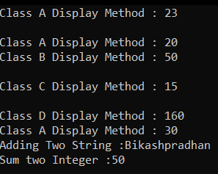

**11. Demonstrate Windows form with different Controls like Layout, Labels, TextBoxes and Buttons, GroupBoxes and Panels, CheckBoxes and RadioButtons, ToolTips, Mouse-Event Handling, Keyboard-Event Handling. Menus, MonthhCalendorControl, Date TimePicker Control, LinkLabel Control, ListBox Control, CheckedListBoxControl, ComboBox Control, TreeView Control, ListView Control, TabControl Control and Multiple Document Interface (MDI) Windows.**

using System;

using System.Collections.Generic;

using System.ComponentModel;

using System.Data;

using System.Drawing;

using System.Linq;

using System.Text;

using System.Threading.Tasks;

using System.Windows.Forms;

using System.IO;

namespace cont

{

public partial class Form1 : Form

{

String selectedText,exam;

String h = "";

public Form1()

{

InitializeComponent();

}

private void radioButton1_CheckedChanged(object sender, EventArgs e)

{

if (((RadioButton)sender).Checked)

{

selectedText = ((RadioButton)sender).Text;

}

}

private void checkBox1_CheckedChanged(object sender, EventArgs e)

{

}

private void selecthobby_Enter(object sender, EventArgs e)

{

}

private void button1_Click(object sender, EventArgs e)

{

foreach (String hob in checkedListBox1.CheckedItems)

{

if(h=="")

{

h = h + hob;

}

else

{

h = h + ","+hob;

}

}

for(int i=0; i<listView1.Items.Count; i++)

{

if(listView1.Items[i].Checked)

{

if(exam=="")

{

exam = listView1.Items[i].Text;

}

else

{

exam = exam + ","+ listView1.Items[i].Text;

}

}

}

dataGridView1.Rows.Add(name.Text, selectedText, h,

dateTimePicker1.Value.ToShortDateString(),comboBox1.SelectedItem,tree.SelectedNode.Te

xt,exam);

}

private void panel1_Paint(object sender, PaintEventArgs e)

{

}

private void checkedListBox1_SelectedIndexChanged(object sender, EventArgs e)

{

}

private void comboBox1_SelectedIndexChanged(object sender, EventArgs e)

{

}

}

}

